Vocabulary Word | Definition | Picture | Learn more…
absolute value | the distance a number is from zero  The answer will always be positive (+). | 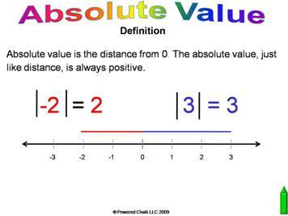
coordinate graph | a graph with the x-axis and y-axis that you can plot ordered pairs on | 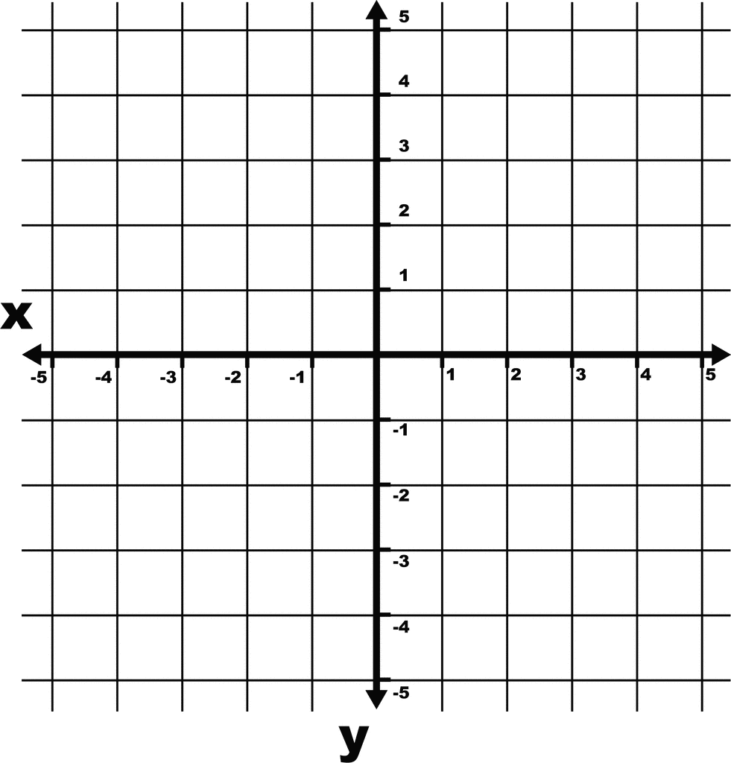  etc.usf.edu
decimal  (point) | a dot or point that splits up a number to show place value  It separates the ones from the tenths in the number.  decimal point  25.39  ones tenths | 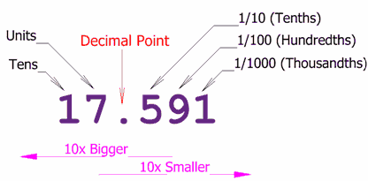  http://www.mathsisfun.com/
equivalent fractions | fractions that equal each other, but have different denominators  How do I make an equivalent fraction?  Multiply or divide each fraction (top and bottom) by the same number.  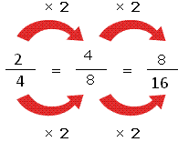  http://mathterms.edublogs.org/ | 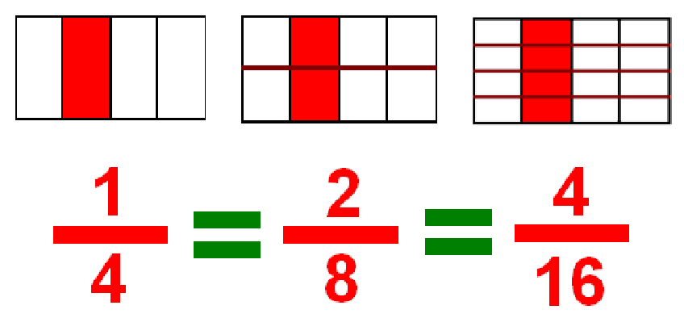  http://michelelawrence.net/ | http://www.coolmath4kids.com/fractions/fractions-04-equivalent-01.html  http://www.mathsisfun.com/equivalent_fractions.html  Equivalent Fraction Game http://www.sheppardsoftware.com/mathgames/fractions/memory_equivalent1.htm
equivalent ratios | ratios that have the same value, but look different  How do I make an equivalent ratio?  Multiply or divide each number in the ratio by the same number.  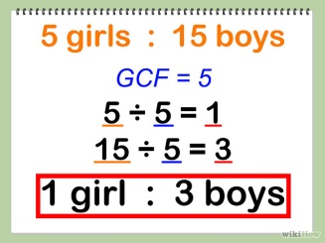 | 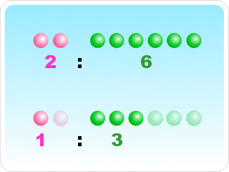  http://www.mathematicsdictionary.com/
fraction | a part of a whole  part  whole | There are 3 pieces of pizza left out of a total of 4 pieces = ¾  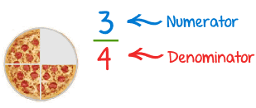  mathisfun.com | More Information:  http://www.mathsisfun.com/fractions.html  Fractions Games:  http://www.mathwarehouse.com/games/our-games/fraction-games/
greatest common factor  (GCF) | the biggest common (same number) factor between two (or more) numbers | 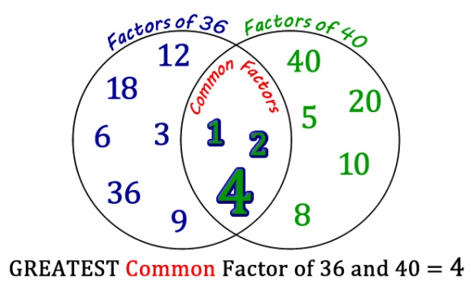  http://edtech2.boisestate.edu/ | http://www.mathsisfun.com/greatest-common-factor.html  another way to find the GCF  http://www.math.com/school/subject1/lessons/S1U3L2GL.html
integers | the counting numbers; can be positive (+) or negative (-)  Integers can NOT be fractions. |  | http://www.mathsisfun.com/whole-numbers.html  Adding and Subtracting Integers  http://www.mathsisfun.com/positive-negative-integers.html
least common multiple | the smallest common multiple of two or more numbers  common = same | 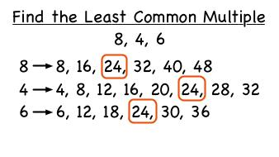  www.prometheanplanet.com
lowest terms | the smallest a fraction can be made | 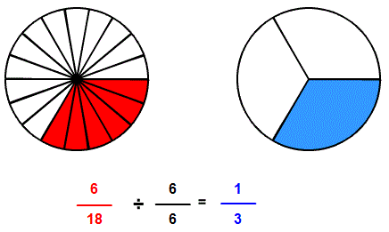
Multiplicative Identity | any number multiplied by 1 will give you the same number  5 * 1 = 5  1,238 * 1 = 1,238 | 3 * = 21  4 * = 28  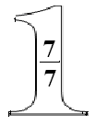  The giant one can be used to make equivalent fractions.  http://en.wikiversity.org/
opposite (number) | the same number with the other sign (+/-)  Opposite numbers:  +5 and -5  +10 and -10  -243 and +243 | 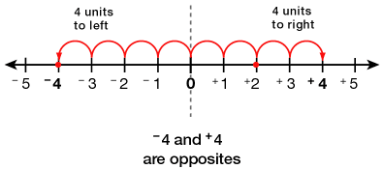  http://www.eduplace.com/
ordered pair | a pair of numbers used to locate a point on the coordinate plane  Hint: Run (horizontal) before you jump (vertical)!  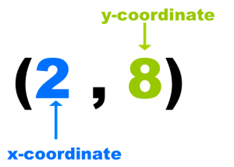  adapted from: http://www.webquest.hawaii.edu/kahihi/mathdictionary/O/orderedpair.php | 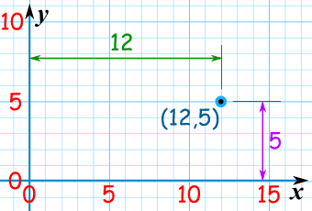  http://www.mathsisfun.com/ | http://www.mathsisfun.com/definitions/ordered-pair.html
origin | the point where the y-axis and the x-axis meet  (0,0) | 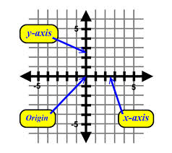  http://zonalandeducation.com/
percent | a number out of 100  percentage sign = %  67 = 67%  100 | 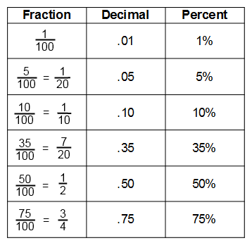  http://www.math4ged.com/ | http://www.mathsisfun.com/percentage.html
point | an exact spot on a coordinate graph  A, B, C, D, and E are all points on this coordinate graph. | .  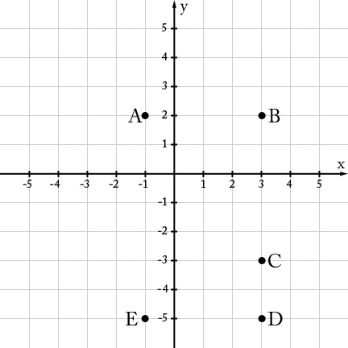  www.illustrativemathematics.org
portion | a part of something  a part of a whole  Your portion of the pie is one slice. | .  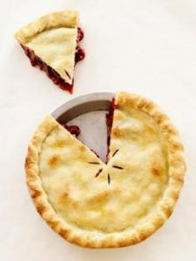  part  (portion)  http://networksboise.wordpress.com/
prime factors | a factor that is also a prime number (a number with only two factors, one and that number)  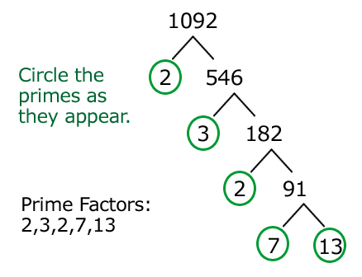 http://javarevisited.blogspot.com/ | 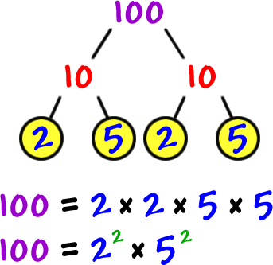  http://coolmath.com/ | Review prime numbers:  http://www.mathsisfun.com/prime_numbers.html
quadrant | one of the four areas in a coordinate plane | 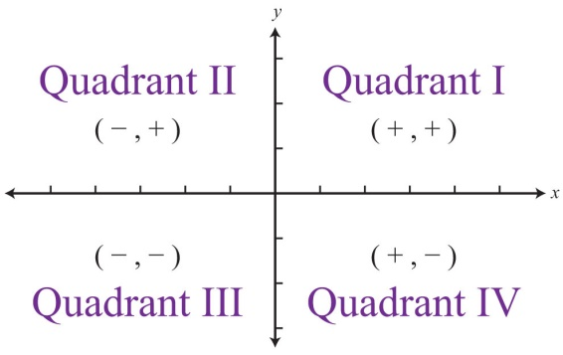  http://catalog.flatworldknowledge.com/
ratio | a comparison of two groups  3 Ways to Write Ratios  to 5 girls to 15 boys  : 5 girls : 15 boys  fraction 5 girls  15 boys | 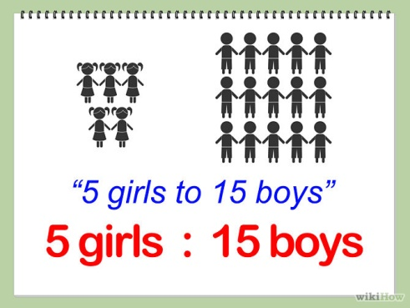
sample | a smaller group used to represent what the larger group is like or thinks  Instead of asking every 6th grader what his or her favorite snack is, you could ask only 20 students and use that to represent the whole class. | 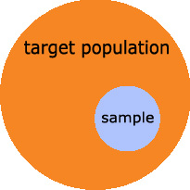  http://www.urbanforestanalytics.com/
scale drawing | the ratio between the length of a drawing or model compared to its length in real life  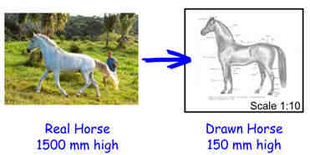  http://www.mathsisfun.com/ | 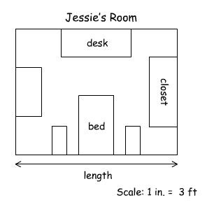  http://www.learningpod.com/ | http://www.basic-mathematics.com/scale-drawings.html
simplify | to change an expression to be easier to understand  *no parentheses  2x(5+3)  *no like terms  5a + 2a | 5x - 3x +7  simplified: 2x +7 | Simplifying Expressions: http://www.mathsisfun.com/algebra/simplify.html  Simplifying Fractions:  http://www.mathsisfun.com/simplifying-fractions.html
whole | the total or all of something  The lady was so hungry she ate the WHOLE pizza!  http://www.fitsugar.com/ | 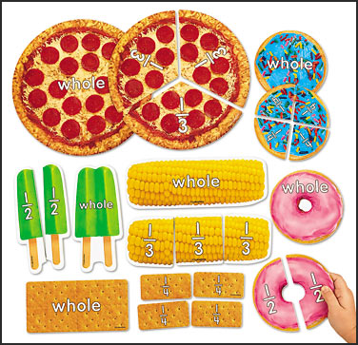  http://maribelochoa09.blogspot.com/
x –axis | x –axis- horizontal line on a coordinate grid | 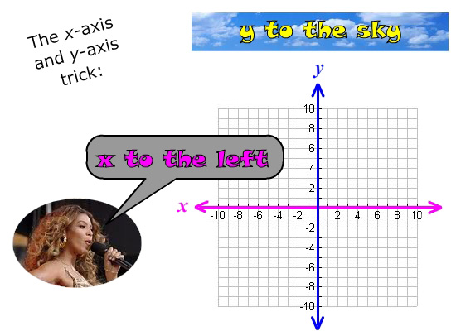  http://www.gradeamathhelp.com/
y-axis | y-axis- vertical line on a coordinate grid | http://www.gradeamathhelp.com/
y-coordinate | the second (2nd) number in an ordered pair | 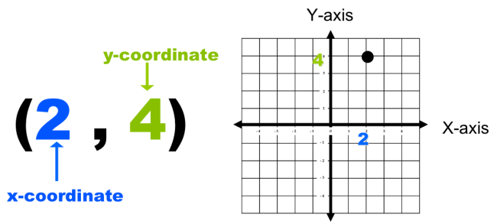  http://www.studyblue.com/

