Vocabulary Word | Definition | Picture | Learn more…
Additive Inverse | adding the opposite of a number in order to get an answer of 0 | 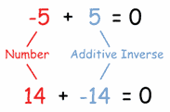  www.mathisfun.com
algebraic expression | math phrase that combines numbers AND variables (letters: 3b or 5x) by using  (+, -, *, ÷)  *does not have an equal sign (=) | 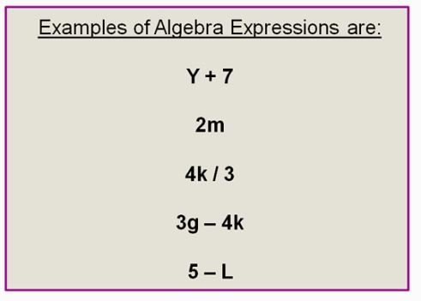  http://passyworldofmathematics.com/
Associative Property | in adding or multiplying, the way in which numbers/ variables are grouped does not change the answer  This only works for adding (+) and multiplying (*).  It does not work for subtracting (-) or dividing (÷). | (a * b) * c = a * (b * c)  (4 * 5) *2 = 4 * (5 * 2)  20 * 2 = 4 * 10  40 = 40
Commutative Property | in adding or multiplying, changing the order of the numbers/variables does not change the answer  This only works for adding (+) and multiplying (*).  It does not work for subtracting (-) or dividing (÷). | Addition:  a + b = b + a  4 + 6 = 6 + 4  10 = 10  Multiplication:  a * b = b * a  4 * 6 = 6 * 4  24 = 24
evaluate | to put in numbers for the variables (letters) in an algebraic expression | Evaluating an algebraic expression:  6b + 5 where b = 2  (6 * 2) + 5  12 + 5  17 | Watch a video:  http://www.mathplanet.com/education/pre-algebra/introducing-algebra/evaluate-expressions
integers | the counting numbers; can be positive (+) or negative (-)  Integers can NOT be fractions. |  | http://www.mathsisfun.com/whole-numbers.html  Adding and Subtracting Integers  http://www.mathsisfun.com/positive-negative-integers.html
Multiplicative Inverse | another name for a reciprocal  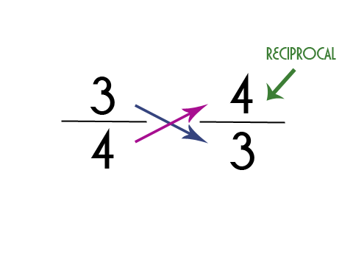  http://mravery.edublogs.org/ | 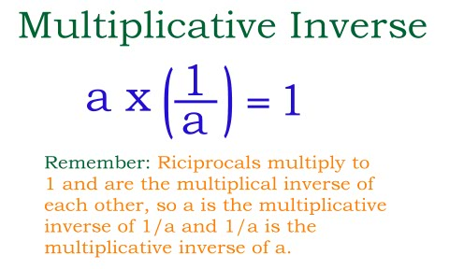  http://www.printable-math-worksheets.com/ | http://coolmath.com/prealgebra/06-properties/09-properties-multiplicative-inverse-01.htm
numerical term | numbers or products of numbers | Numerical term  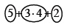  http://textbooks.cpm.org/
Order of Operations | the order to evaluate or simplify an expression  - Parentheses ( )  - Exponents 5²  - Multiplication (*) and Division (÷) (left to right )  - Addition (+) and Subtraction (-) (left to right ) | 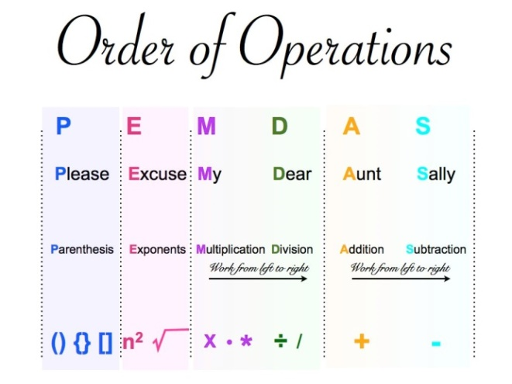  http://www.kidzucation.com/ | http://www.mathsisfun.com/operation-order-pemdas.html
quotient | the answer of a division problem | 14 ÷ 7= 2  quotient
rational numbers | numbers that can be written in a/b form or as a fraction  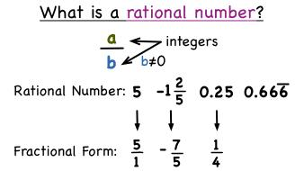  http://bhillmath.weebly.com/ | 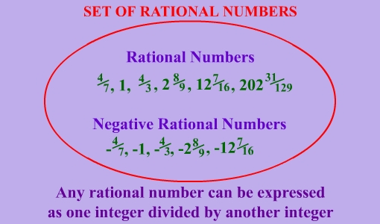  http://www.webovations.com/
reciprocals | To find the reciprocal of whole number:  Write the number as a fraction over one and then flip it.  reciprocal  13 1  1 13  To find the reciprocal of a fraction:  Flip the fraction.  7 9  9 7  reciprocal | http://mravery.edublogs.org/
simplify | to change an expression to be easier to understand  *no parentheses  2x(5+3)  *no like terms  5a + 2a | 5x -3x +7  simplified: 2x +7 | Simplifying Expressions: http://www.mathsisfun.com/algebra/simplify.html  Simplifying Fractions:  http://www.mathsisfun.com/simplifying-fractions.html
substitution | replacing a variable with a number or expression | 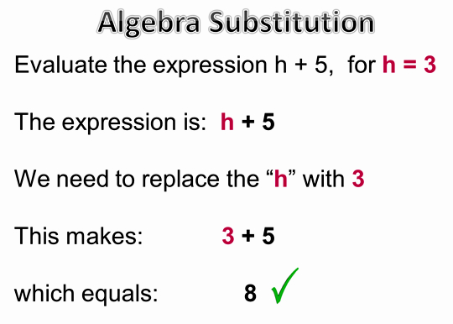  http://passyworldofmathematics.com/
terms | a number, a variable, or a number multiplied by variable/variables | Number = 23  Variable = b  Number and Variable(s) = 12y or 5ab

