Vocabulary Word | Definition | Picture | Learn more…
graph | a way to show numbers or data with a picture | 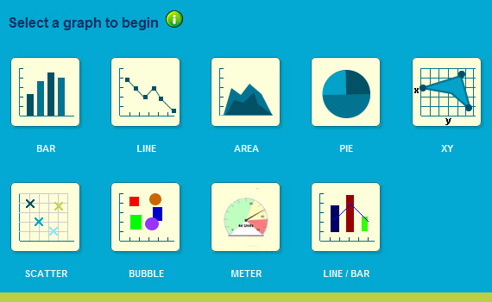  Types of Graphs  http://www.1stwebdesigner.com/
growth triangle | a right triangle that is made on a graph in order to find the slope | 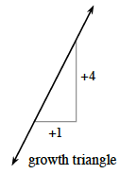  change in y-value  change in x-value  The line makes the hypotenuse of the growth triangle.  adapted from textbooks.cpm.org
parabola | U-shaped curve on a graph  y = ax² + bx +c  where a does not equal 0  (can open up or down) | 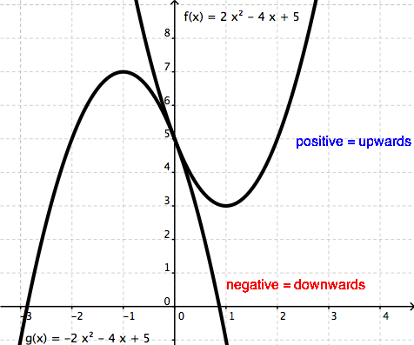  http://www.wyzant.com/
parameter | in an equation with x and y variables, there are usually parameters (like the m and b variables below) that are usually replaced with numbers  y = mx + b  slope y-intercept | 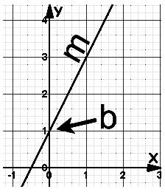  http://www.optimizesmart.com/
rule | the math that needs to be done to get from the input to the output  Sample rules:  - Add 5  - Divide by 3, then add 2  - Multiply by 7, then subtract 1 | Input Output  5 13  6 15  9 21  10 23  The rule here is to multiply by 2 and add 3.
solution | the answer(s) to an equation  or inequality ≤ | 10 = x + 3  -3 = - 3  7 = x  7 is the solution for this equation
tile pattern | figures made of algebra tiles that change in a pattern by the same amount each time.  Each figure to the right adds 2 tiles. | 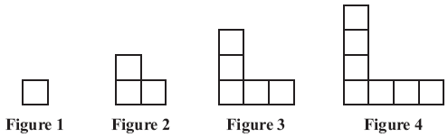  +2  +2  +2  www.doe.mass.edu
variable | a letter that represents an unknown value | 2x + 8 – 9y  Variables
xy table | a way to organize data, also known as an input and output table  The table can be used to make a graph and/or to organize data. | 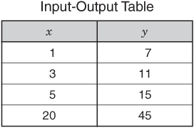  http://ssrsbstaff.ednet.ns.ca/
y-intercept | the point where a line meets the y-axis  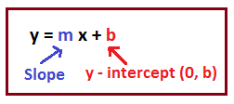  http://math.tutorvista.com/ | 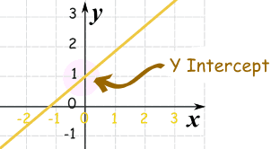  http://www.mathsisfun.com/

