Vocabulary Word | Definition | Picture | Learn more…
5-D Process | a way to solve a mathematical problem using trial and error to find the answer  - Describe/Draw  - Define  - Do  - Decide  - Declare | Describe/Draw: The shape is a rectangle, and we are looking at the perimeter.  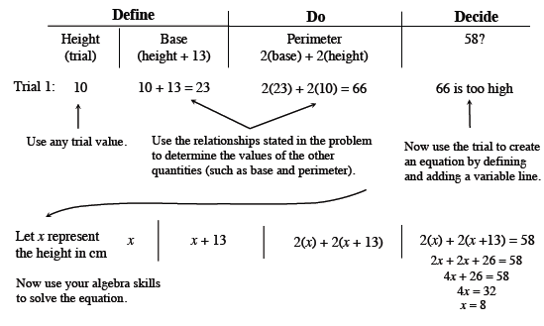  - Declare: The base is 21 centimeters, and the height is 8 centimeters.  - Example from http://textbooks.cpm.org/
area | the amount of space INSIDE a shape | 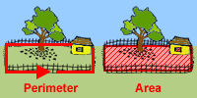  Area is the space INSIDE the fence.  http://www.mathgoodies.com/ | http://www.mathsisfun.com/geometry/area.html  area vs. perimeter  http://www.bgfl.org/bgfl/custom/resources_ftp/client_ftp/ks2/maths/perimeter_and_area/index.html
box plot | a way to visually show many kinds of data (minimum, maximum, range, median, 1st quartile, and 3rd quartile) | 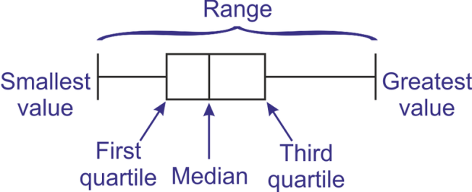  mathisfun.com | Video on how to make a box plot:  https://learnzillion.com/lessons/2961-create-a-box-plot  more information:  http://www.mathsisfun.com/data/quartiles.html
coordinates | the numbers that show you a point/location on a coordinate grid or can also be found in an ordered pair (x-coordinate first, then y-coordinate)  *see ordered pair | 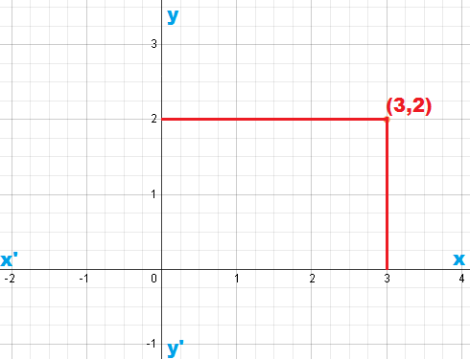  http://math.tutorvista.com/
dependent variable | this variable depends on the value of another variable  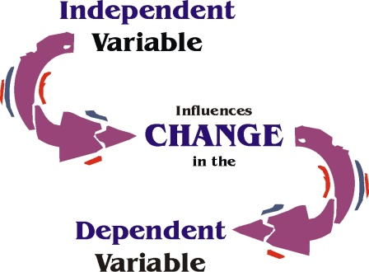  http://arose.iweb.bsu.edu/  It is usually shown as the output value in a table. | 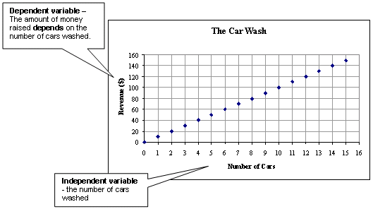  astro.virginia.edu
histogram | a special type of bar graph that shows a range for each bar  The range should be equal amounts for all bars. | 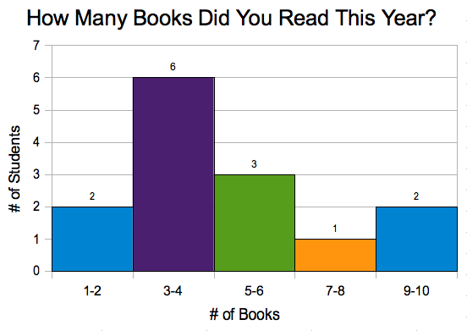  avoca37.org | http://www.studyzone.org/mtestprep/math8/e/histogram6l.cfm  http://www.mathsisfun.com/data/histograms.html
independent variable | this variable will change the value of another variable  http://arose.iweb.bsu.edu/  It is usually shown as the input value in a table. | astro.virginia.edu
integers | the counting numbers; can be positive (+) or negative (-)  Integers can NOT be fractions. |  | http://www.mathsisfun.com/whole-numbers.html  Adding and Subtracting Integers  http://www.mathsisfun.com/positive-negative-integers.html
input value | the value you put in changes the value of the other variable  The input value is the independent variable (usually the x variable). | Independent variable dependent variable  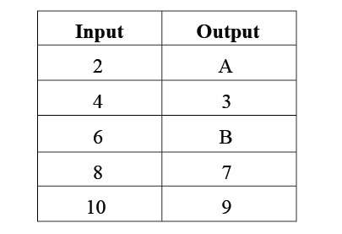  http://www.mathblaster.com/
mean | a way to measure data by:  - adding up all numbers  - divide that by how many numbers were added  (also known as the “average”) | 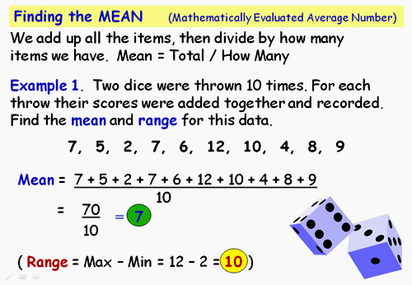  http://passyworldofmathematics.com/
median | a way to measure data by putting all of the numbers in order and then finding the middle number  If there are two middle numbers, add the two numbers together and divide by two to find the median. | 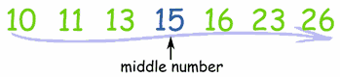  www.mathisfun.com
ordered pair | a pair of numbers used to locate a point on the coordinate plane  Hint: Run (horizontal) before you jump (vertical)!  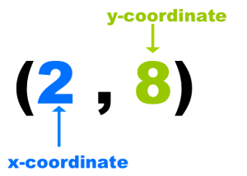  adapted from: http://www.webquest.hawaii.edu/kahihi/mathdictionary/O/orderedpair.php | 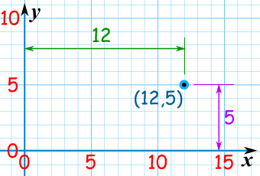  http://www.mathsisfun.com/ | http://www.mathsisfun.com/definitions/ordered-pair.html
origin | the point where the y-axis and the x-axis meet  (0,0) | 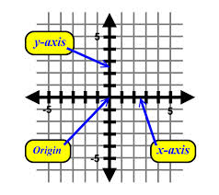  http://zonalandeducation.com/
output value | the value that comes out is changed by the input value  The output value is the dependent variable (usually the y variable). | Independent variable dependent variable  http://www.mathblaster.com/
perimeter | the distance AROUND an object | 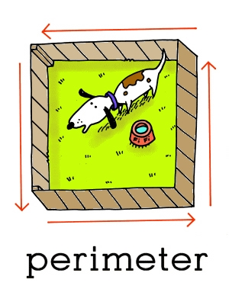  www.leslienettling.com | http://www.mathsisfun.com/geometry/perimeter.html  area vs. perimeter http://www.bgfl.org/bgfl/custom/resources_ftp/client_ftp/ks2/maths/perimeter_and_area/index.html
proportion | two ratios that are equal | mathisfun.com
proportional relationship | two amounts that have the same ratio  Example:  If you babysit for 1 hour, you will get paid $9.00. If you babysit for 3 hours, you will get paid $27.  1 hour = 3hours  $9.00 = $27.00  When one is multiplied by 3, the other number is multiplied by 3. | 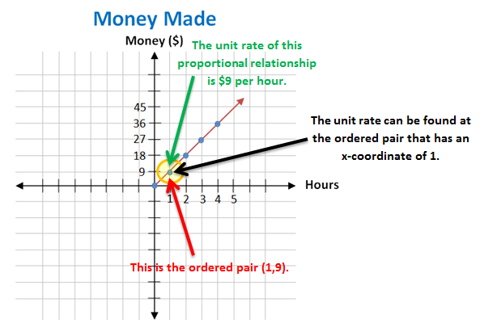  gcps.desire2learn.com
quadrant | one of the four areas in a coordinate plane | 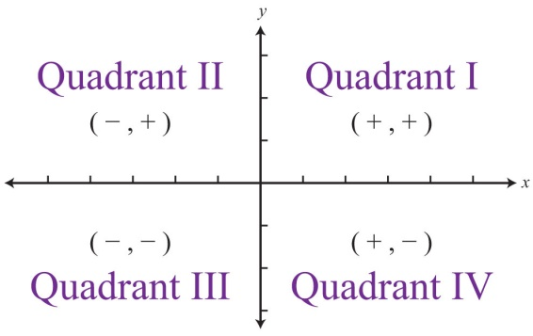  http://catalog.flatworldknowledge.com/
stem-and-leaf plot | a way to organize data into a chart  Stem= first digit(s) of the number  Leaf= the last digit of the number | 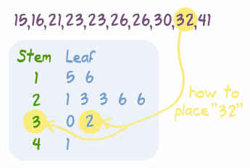  mathisfun.com | Watch a video on how to make a stem-and-leaf plot:  http://www.mathplayground.com/howto_stemleaf.html
unit rate | a rate with a denominator of 1  $8.00  1 hour of babysitting  $0.75  1 apple  4 game tokens  $1.00 | 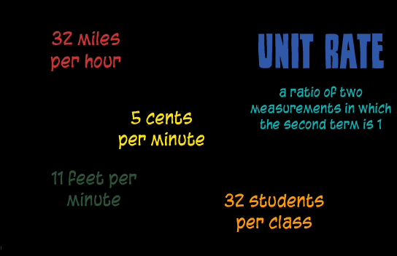  gcps.desire2learn.com
variable | a letter that represents an unknown value | 2x + 8 – 9y  variables
x-axis | x –axis- horizontal line on a coordinate grid | 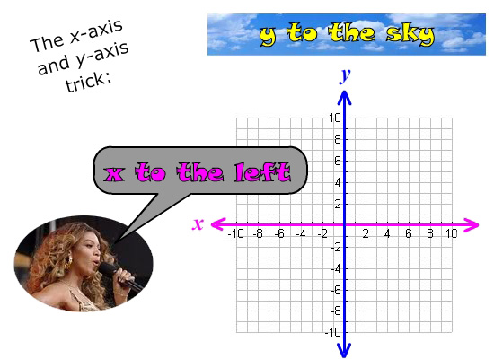  http://www.gradeamathhelp.com/
y-axis | y-axis- vertical line on a coordinate grid | http://www.gradeamathhelp.com/

