Vocabulary Word | Definition | Picture | Learn more…
Additive Identity | adding the number 0 to any number does not change the value  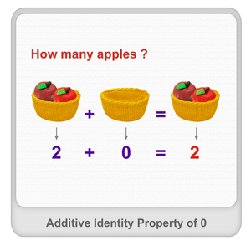  www.splashmath.com | 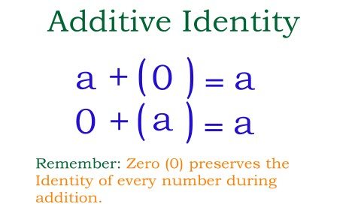  http://www.printable-math-worksheets.com/
Additive Inverse | adding the opposite of a number in order to get an answer of 0 | 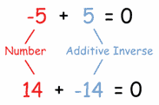  www.mathisfun.com
Associative Property | in adding or multiplying, the way in which numbers/ variables are grouped does not change the answer  This only works for adding (+) and multiplying (*).  It does not work for subtracting (-) or dividing (÷). | (a * b) * c = a * (b * c)  (4 * 5) *2 = 4 * (5 * 2)  20 * 2 = 4 * 10  40 = 40
combining like terms | combining terms (by adding or subtracting) that are similar to each other | 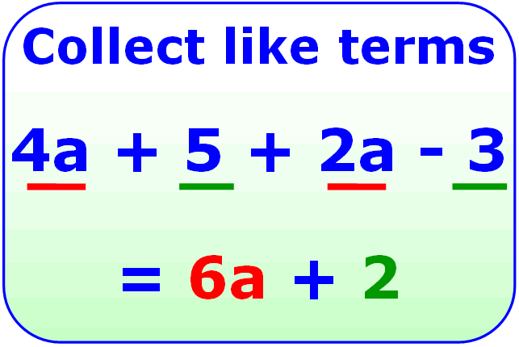  http://mjnwsu132.wordpress.com/ | http://www.mathsisfun.com/algebra/like-terms.html
Commutative Property | in adding or multiplying, changing the order of the numbers/variables does not change the answer  This only works for adding (+) and multiplying (*).  It does not work for subtracting (-) or dividing (÷). | Addition:  a + b = b + a  4 + 6 = 6 + 4  10 = 10  Multiplication:  a * b = b * a  4 * 6 = 6 * 4  24 = 24
Equation Mat | two expression mats put together with an equal sign to find the number(s) that make the expressions equal =  (adapted from textbooks.cpm.org) | Equation Mat  (has equal sign)  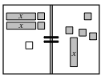  textbooks.cpm.org
evaluate | to put in numbers for the variables (letters) in an algebraic expression | Evaluating an algebraic expression:  6b + 5 where b = 2  (6 * 2) + 5  12 + 5  17 | Watch a video:  http://www.mathplanet.com/education/pre-algebra/introducing-algebra/evaluate-expressions
Expression Comparison Mat | two expression mats put next to each other to decide which one has a greater value | 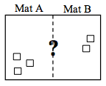  textbooks.cpm.org
Multiplicative Identity | any number multiplied by 1 will give you the same number  5 * 1 = 5  1,238 * 1 = 1,238 | 3 * = 21  4 * = 28  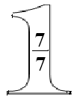  The giant one can be used to make equivalent fractions.  http://en.wikiversity.org/
Multiplicative Inverse | another name for a reciprocal  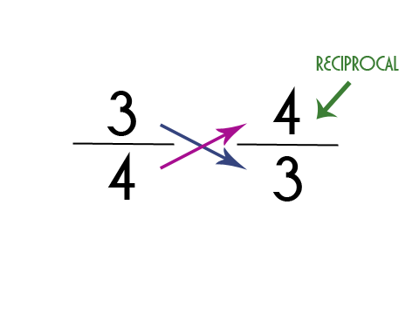  http://mravery.edublogs.org/ | 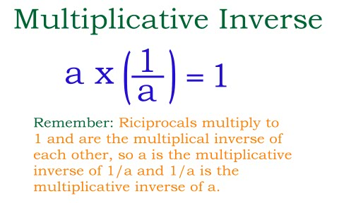  http://www.printable-math-worksheets.com/ | http://coolmath.com/prealgebra/06-properties/09-properties-multiplicative-inverse-01.htm
non-commensurate | when no whole number multiple of one measurement can ever equal a whole number multiple of the other  from textbooks.cpm.org | 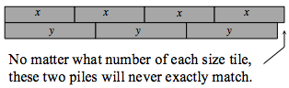  textbooks.cpm.org
Order of Operations | the order to evaluate or simplify an expression  - Parentheses ( )  - Exponents 5²  - Multiplication (*) and Division (÷) (left to right )  - Addition (+) and Subtraction (-) (left to right ) | 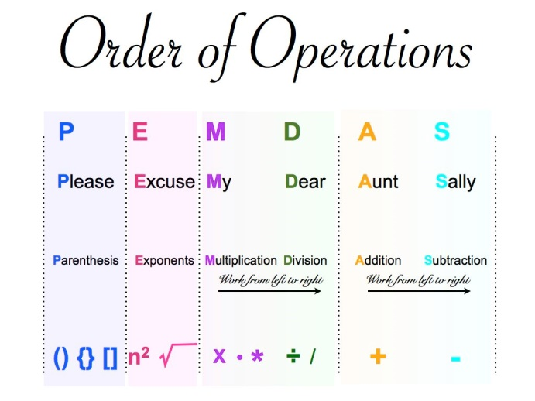  http://www.kidzucation.com/
term | a number, a variable, or a number multiplied by variable/variables | Number = 23  Variable = b  Number and Variable(s) = 12y or 5ab
variable | a letter that represents an unknown value | 2x + 8 – 9y  variables

