Vocabulary Word | Definition | Picture | Learn more…
algebraic expression | math phrase that combines numbers AND variables (letters: 3b or 5x) by using  (+, -, *, ÷)  *does not have an equal sign (=) | 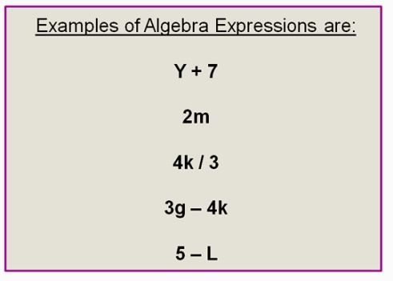  http://passyworldofmathematics.com/
enlarge | to make bigger  This figure was enlarged 3 times or by 300%. | 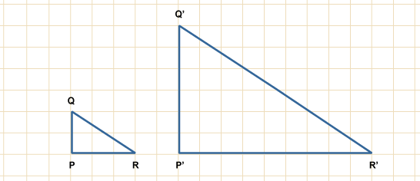  http://www.bbc.co.uk/
equivalent expressions | two different ways to write the same expression | 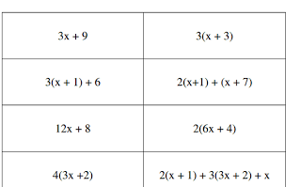  http://www.algebra1teachers.com/
equivalent fractions | fractions that equal each other, but have different denominators  How do I make an equivalent fraction?  Multiply or divide each fraction (top and bottom) by the same number.  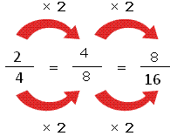  http://mathterms.edublogs.org/ | 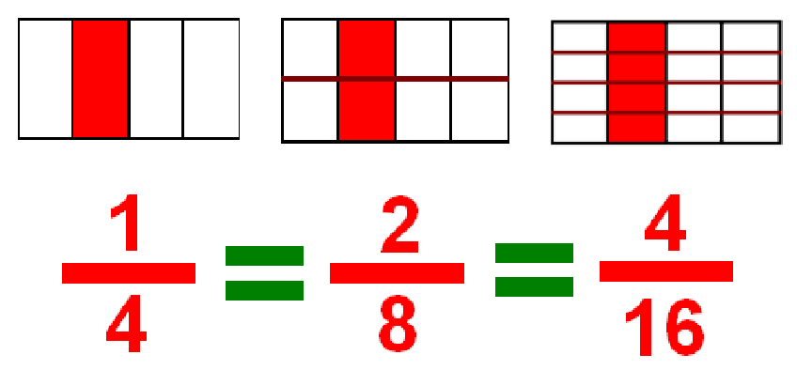  http://michelelawrence.net/ | http://www.coolmath4kids.com/fractions/fractions-04-equivalent-01.html  http://www.mathsisfun.com/equivalent_fractions.html  Equivalent Fraction Game http://www.sheppardsoftware.com/mathgames/fractions/memory_equivalent1.htm
equivalent ratios | ratios that have the same value, but look different  How do I make an equivalent ratio?  Multiply or divide each number in the ratio by the same number.  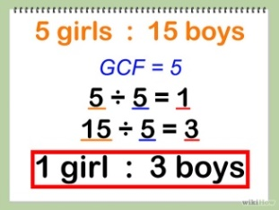 | 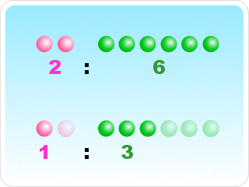  http://www.mathematicsdictionary.com/
expression | math phrase that combines numbers by using +, -, *, or ÷  An expression does not have an equal sign (=). | -5 + 11  7 * 3  10 – 2 + 5 +3 | http://www.mathsisfun.com/definitions/expression.html
evaluate | to replace variables (letters) with numbers in an algebraic expression | Evaluating an algebraic expression:  6b + 5 where b = 2  (6 * 2) + 5  12 + 5  17 | Watch a video:  http://www.mathplanet.com/education/pre-algebra/introducing-algebra/evaluate-expressions
ratio | a comparison of two groups  3 Ways to Write Ratios  to 5 girls to 15 boys  : 5 girls : 15 boys  fraction 5 girls  15 boys | 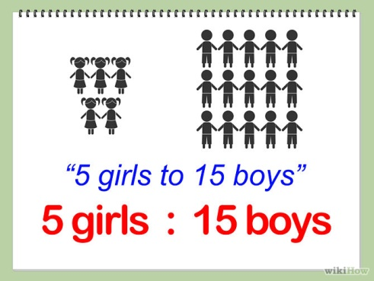
reduce | to make smaller  Fractions can also be reduced to lowest terms. | 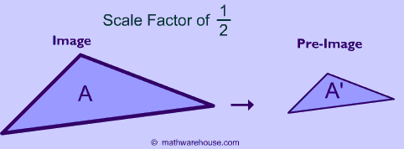  Fraction reduced to lowest terms:  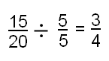 http://www.wyzant.com/
similar figures | figures that have the same shape, but not the same size | 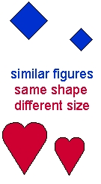  http://www.beaconlearningcenter.com/ | More practice:  http://www.beaconlearningcenter.com/weblessons/samssimilarshapes/default.htm
substitution | replacing a variable with a number or expression | 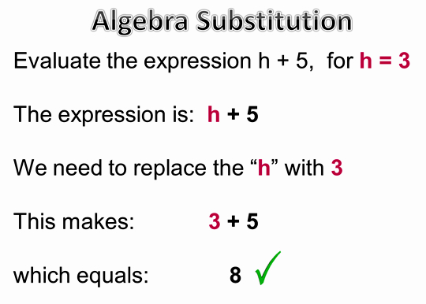  http://passyworldofmathematics.com/
variable | a letter that represents an unknown value | 2x + 8 – 9y  variables
vertex (vertices) | the point where two lines or rays meet  vertices = more than one vertex  can also be a corner of a shape | 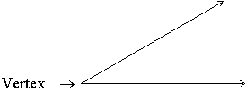  http://www.resourcechannel.org/  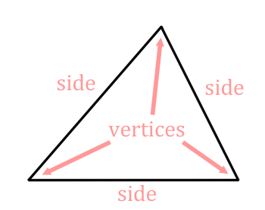  www.mathguide.com

