Vocabulary Word | Definition | Picture | Learn more…
area | the amount of space INSIDE a shape | 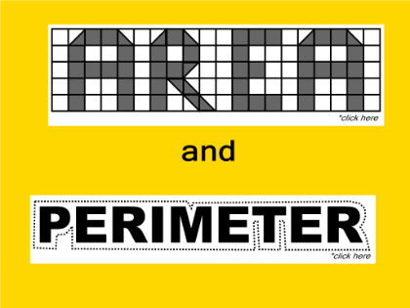 | http://www.mathsisfun.com/geometry/area.html  area vs. perimeter  http://www.bgfl.org/bgfl/custom/resources_ftp/client_ftp/ks2/maths/perimeter_and_area/index.html
composite number | a number that has more than two factors | 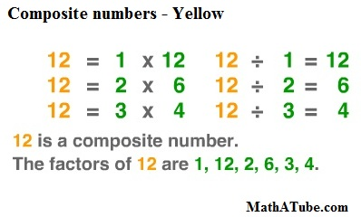 | Watch a video:  http://www.mathsisfun.com/prime-composite-number.html
even number | a whole number that can be divided by 2  10 ÷ 2 = 5 (10 is whole number)  Examples:  2, 4, 6, 8, 10, 12, 14, 16, 18, 20, 22…… | 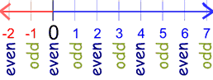  mathisfun.com | http://www.mathsisfun.com/definitions/even-number.html
expression | math phrase that combines numbers by using (+ or -)  Does not have an equal sign (=) | -5 + 11  7 – 3  10 – 2 + 5 +3 | http://www.mathsisfun.com/definitions/expression.html
factor | a number that can be divided evenly by a larger number  24 ÷ 4 = 6  24 ÷ 6 = 4  6 and 4 are both factors of 24 | 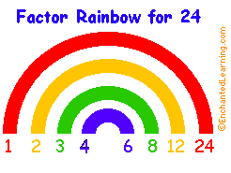  1 * 24 = 24  2 * 12 = 24  3 * 8 = 24  4 * 6 = 24  1, 2, 3, 4, 6, 8, 12, & 24 are all factors of 24 | http://www.mathsisfun.com/definitions/factor.html
histogram | a special type of bar graph that has a range  The range should be equal. | 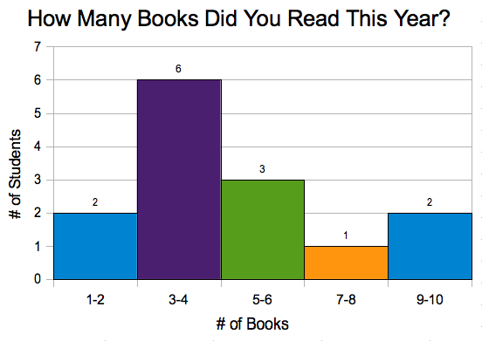  avoca37.org | http://www.studyzone.org/mtestprep/math8/e/histogram6l.cfm  http://www.mathsisfun.com/data/histograms.html
multiple | when a whole number is multiplied by another whole number, the product or ANSWER is a multiple of that number  4 * 2 = 8 (8 is a multiple of 4)  Multiples of 4:  4, 8, 12, 16, 20, 24, 28, 32, 36, 40, 44, 48, 52, 56, 60, 64, etc… | 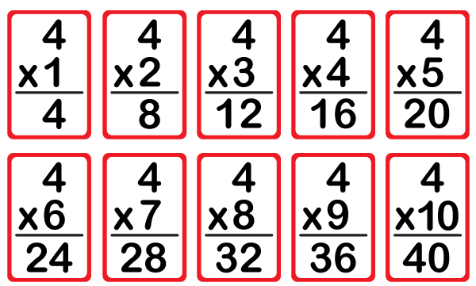  www.mathrise.com | For extra practice:  http://jmathpage.com/JIMSMultiplicationfactorsandmultiples.html  http://www.mathsisfun.com/definitions/multiple.html
odd number | a whole number that can NOT be divided by 2 (without a remainder)  Examples:  1, 3, 5, 7, 9, 11, 13, 15, 17, 19, 21….. |  | http://www.mathsisfun.com/definitions/odd-number.html
perimeter | the distance around an object | 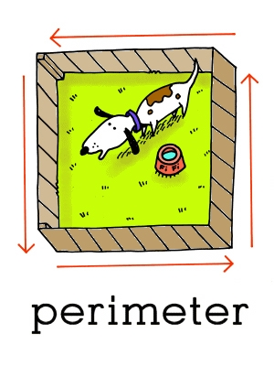  www.leslienettling.com | http://www.mathsisfun.com/geometry/perimeter.html  area vs. perimeter http://www.bgfl.org/bgfl/custom/resources_ftp/client_ftp/ks2/maths/perimeter_and_area/index.html
place value | the value of a number is decided by where it is located | 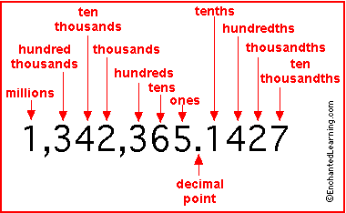 | For extra practice:  http://www.aaamath.com/g12ea_x1.htm  http://www.funbrain.com/tens/
prime number | a number that only has two factors, one and that number  Examples:  7 only has two factors: 1 and 7  19 only has two factors: 1 and 19  Nonexample:  20 has six factors: 1, 2, 4, 5, 10, and 20 | 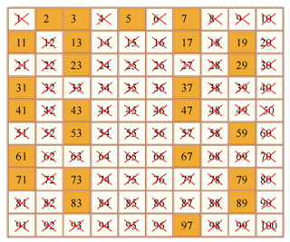  http://ocw.mit.edu/ | Watch a video:  http://www.mathsisfun.com/prime-composite-number.html
product | the answer of two or more numbers/expressions being multiplied | 3 * 4 = 12 (12 is the product)
rectangular array | columns and rows that make a rectangular shape | The different rectangular arrays for 12  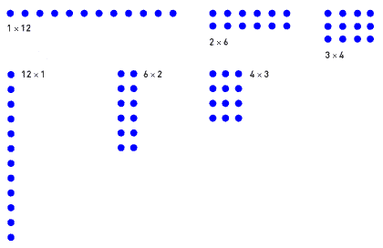  www.learner.org
remainder | what remains or is left after a division problem | 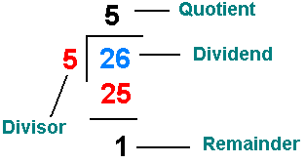  math.tutorvista.com | http://www.mathsisfun.com/definitions/remainder.html
scatter plot | A graph that plots points. It shows how the two sets of data relate to each other.  The graph to the right shows how many hours students study for a test and how that connects to the scores they received on the test. | 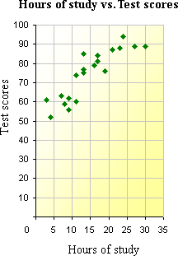  www.icoachmath.com | http://www.mathsisfun.com/data/scatter-xy-plots.html

