Vocabulary Word | Definition | Picture | Learn more…
area | the amount of space INSIDE a shape | 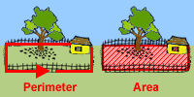  Area is the space INSIDE the fence.  http://www.mathgoodies.com/ | http://www.mathsisfun.com/geometry/area.html  area vs. perimeter  http://www.bgfl.org/bgfl/custom/resources_ftp/client_ftp/ks2/maths/perimeter_and_area/index.html
bar graph | 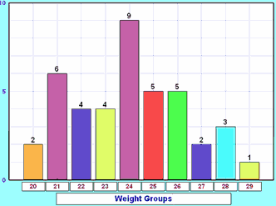  a graph drawn using rectangular bars  The bars can be horizontal or vertical.  mathisfun.com | 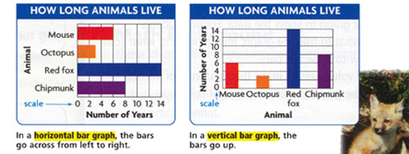 | For extra practice:  http://www.ixl.com/math/grade-6/create-double-bar-graphs
centimeter | a metric unit for length  1 inch = 2.54 centimeters  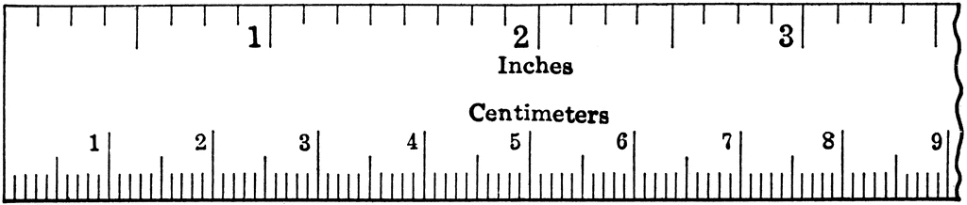  http://www.future-edge.com/ | 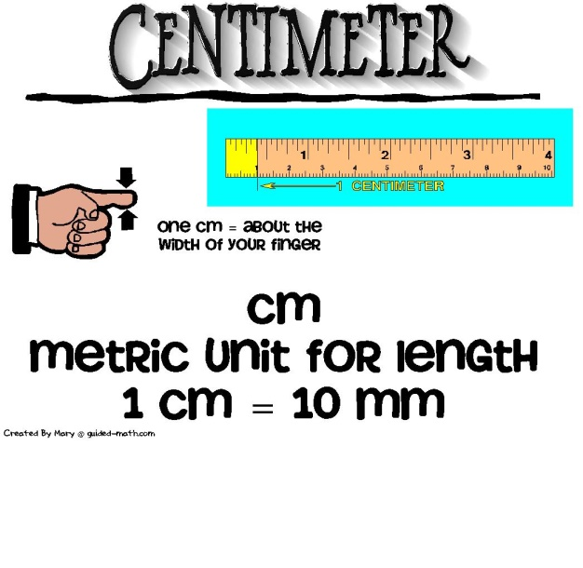 | For extra practice:  http://www.funbrain.com/measure/
expression | math phrase that combines numbers by using +, -, *, or ÷  An expression does not have an equal sign (=). | -5 + 11  7 * 3  10 – 2 + 5 +3 | http://www.mathsisfun.com/definitions/expression.html
generic rectangle | another method or way to multiply numbers | 52 * 34 = ?  50 2  30 1500 60  200 4 8  1500 + 200 + 60 + 8 = 1768
greatest common factor  (GCF) | the biggest common (same number) factor between two (or more) numbers | 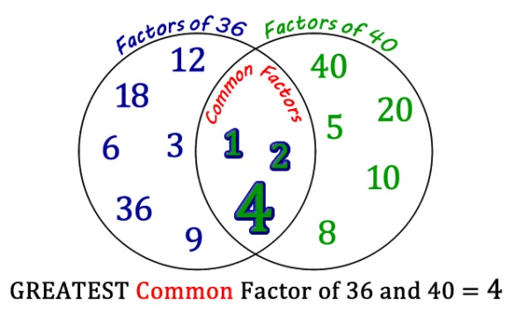  http://edtech2.boisestate.edu/ | http://www.mathsisfun.com/greatest-common-factor.html  another way to find the GCF  http://www.math.com/school/subject1/lessons/S1U3L2GL.html
histogram | a special type of bar graph that shows a range for each bar  The range should be equal amounts for all bars.  The bars in the graph should touch each other. | 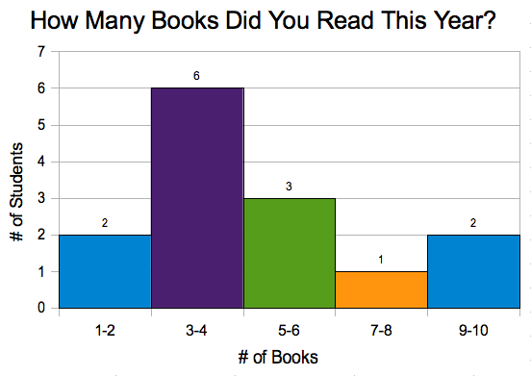  avoca37.org | http://www.studyzone.org/mtestprep/math8/e/histogram6l.cfm  http://www.mathsisfun.com/data/histograms.html
inch | a unit of measurement  There are 12 inches in one foot. | 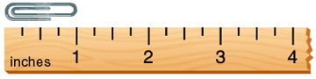  www.eduplace.com | For extra practice:  http://www.funbrain.com/measure/
length | the distance from one side of a figure to the other side | http://areaofrectangle.blogspot.com/
operation | a mathematical process using +, -, *, ÷, √ (square root), or 5³ (exponents). | 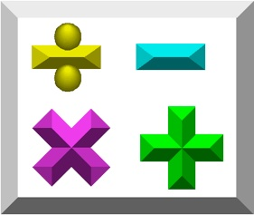  studysmart.com | http://www.mathsisfun.com/definitions/operation.html  Order of Operations (PEMDAS)  http://www.mathsisfun.com/operation-order-pemdas.html
perimeter | the distance AROUND an object | 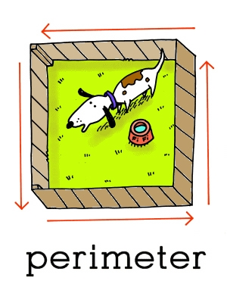  www.leslienettling.com | http://www.mathsisfun.com/geometry/perimeter.html  area vs. perimeter http://www.bgfl.org/bgfl/custom/resources_ftp/client_ftp/ks2/maths/perimeter_and_area/index.html
stem-and-leaf plot | a way to organize data into a chart  Stem= first digit(s) of the number  Leaf= the last digit of the number | 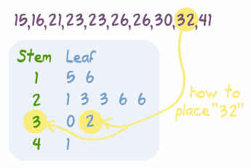  mathisfun.com | Watch a video on how to make a stem-and-leaf plot:  http://www.mathplayground.com/howto_stemleaf.html
unit of measure | a label that is used to show what a number represents  Examples: second, minute, hour, day, week, month, cup, pint, gallon, inch, foot, mile, centimeter, meter, Fahrenheit, etc. | 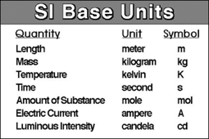  http://education-portal.com/
Venn diagram | a diagram that shows what is the SAME and what is DIFFERENT between two or more things | 