Vocabulary Word | Definition | Picture | Learn more…
algebraic expression | math phrase that combines numbers AND variables (letters: 3b or 5x) by using  (+, -, *, ÷)  *does not have an equal sign (=) | 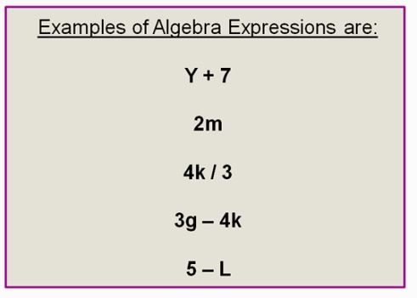  http://passyworldofmathematics.com/
Associative Property | in adding or multiplying, the way in which numbers/ variables are grouped does not change the answer  This only works for adding (+) and multiplying (*).  It does not work for subtracting (-) or dividing (÷). | (a * b) * c = a * (b * c)  (4 * 5) *2 = 4 * (5 * 2)  20 * 2 = 4 * 10  40 = 40
combining like terms | combining terms (by adding or subtracting) that are similar to each other | 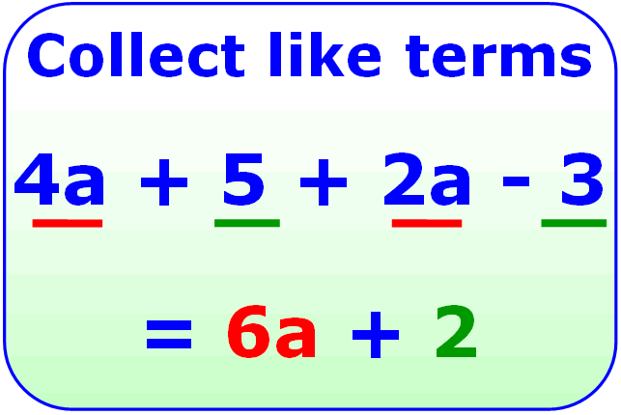  http://mjnwsu132.wordpress.com/ | http://www.mathsisfun.com/algebra/like-terms.html
Commutative Property | in adding or multiplying, changing the order of the numbers/variables does not change the answer  This only works for adding (+) and multiplying (*).  It does not work for subtracting (-) or dividing (÷). | Addition:  a + b = b + a  4 + 6 = 6 + 4  10 = 10  Multiplication:  a * b = b * a  4 * 6 = 6 * 4  24 = 24
constant term | the number in an expression that does not have a variable with it  constant = same | 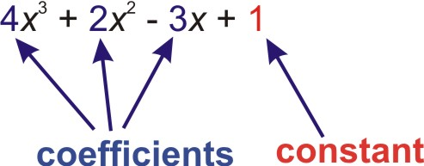  http://www.ck12.org/
constant of proportionality | the equation in proportional relationships is:  y= kx  k = constant of proportionality (it stays the same)  (the slope) | 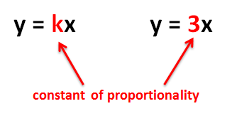  gcps.desire2learn.com
corresponding parts | side or angle that has a matching side or angle on another figure | 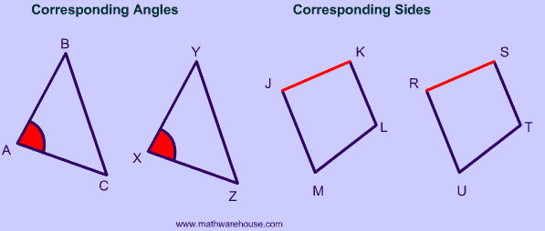 | http://www.mathwarehouse.com/geometry/corresponding-angles-sides.php
Distributive Property | Multiply the number outside of the parenthesis with everything inside the parenthesis.  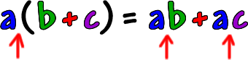  www.coolmath.com | 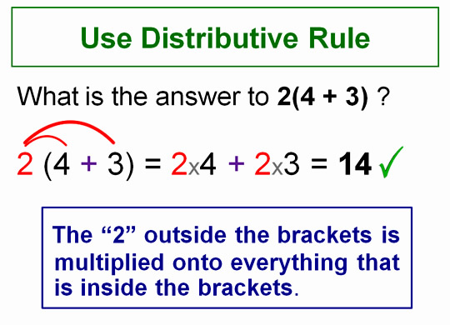  http://passyworldofmathematics.com/
equivalent expressions | two different ways to write the same expression | 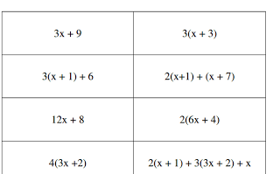  http://www.algebra1teachers.com/
evaluate | to put in numbers for the variables (letters) in an algebraic expression | Evaluating an algebraic expression:  6b + 5 where b = 2  (6 * 2) + 5  12 + 5  17 | Watch a video:  http://www.mathplanet.com/education/pre-algebra/introducing-algebra/evaluate-expressions
proportional relationship | two amounts that have the same ratio  Example:  If you babysit for 1 hour, you will get paid $9.00. If you babysit for 3 hours, you will get paid $27.  1 hour = 3hours  $9.00 = $27.00  When one is multiplied by 3, the other number is multiplied by 3. | 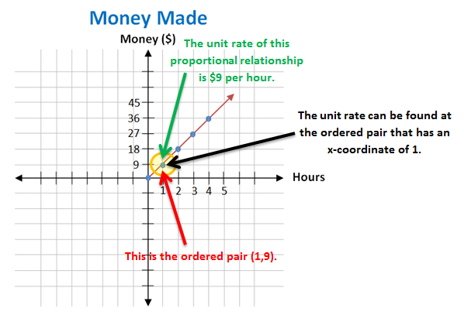  gcps.desire2learn.com
scale drawing | the ratio between the length of a drawing or model compared to its length in real life  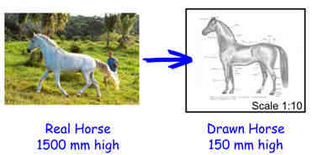  http://www.mathsisfun.com/ | 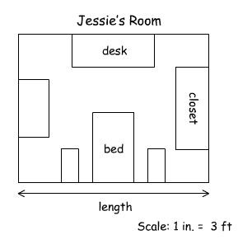  http://www.learningpod.com/ | http://www.mathsisfun.com/definitions/scale.html
scale factor | how much bigger (multiplied) or smaller (divided) two similar shapes are to each other  The scale factor from the smaller object to the larger one is 3. It is 3 times bigger or 300% bigger. | 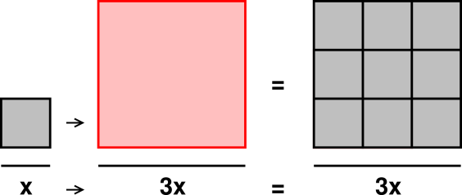  http://www.av8n.com/
similar figures | figures that have the same shape, but not the same size | 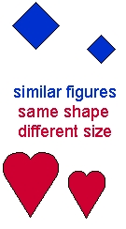  http://www.beaconlearningcenter.com/
simplify | to change an expression to be easier to understand  *no parentheses  2x(5+3)  *no like terms  5a + 2a | 5x -3x +7  simplified: 2x +7 | Simplifying Expressions: http://www.mathsisfun.com/algebra/simplify.html  Simplifying Fractions:  http://www.mathsisfun.com/simplifying-fractions.html
terms | a number, a variable, or a number multiplied by variable/variables | Number = 23  Variable = b  Number and Variable(s) = 12y or 5ab
unit rate | a rate with a denominator of 1  $8.00  1 hour of babysitting  $0.75  1 apple  4 game tokens  $1.00 | 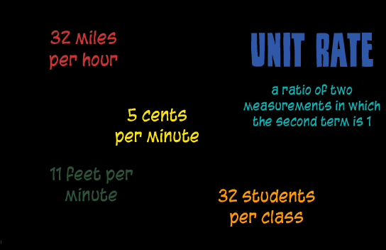  gcps.desire2learn.com
variable | a letter that represents an unknown value | 2x + 8 – 9y  variables

