Vocabulary Word | Definition | Picture | Learn more…
area | the amount of space INSIDE a shape | 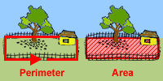  Area is the space INSIDE the fence.  http://www.mathgoodies.com/ | http://www.mathsisfun.com/geometry/area.html  area vs. perimeter  http://www.bgfl.org/bgfl/custom/resources_ftp/client_ftp/ks2/maths/perimeter_and_area/index.html
compound events | the outcome depends on two or more events | 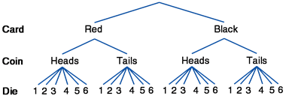  www.shmoop.com
desired outcomes | the outcome you want(ed) to happen | What is the probability of rolling a 5?  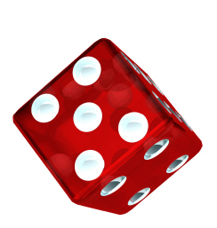  http://www.hallme.com/  The desired outcome is rolling a 5.
equivalent fractions | fractions that equal each other, but have different denominators  How do I make an equivalent fraction?  Multiply or divide each fraction (top and bottom) by the same number.  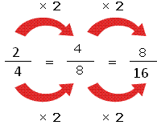  http://mathterms.edublogs.org/ | 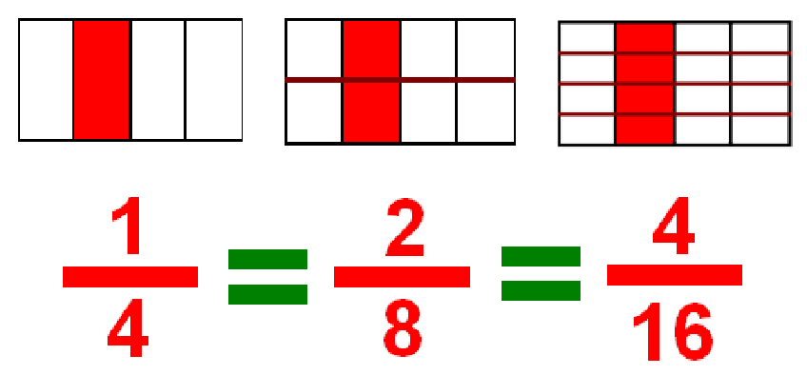  http://michelelawrence.net/ | http://www.coolmath4kids.com/fractions/fractions-04-equivalent-01.html  http://www.mathsisfun.com/equivalent_fractions.html  Equivalent Fraction Game http://www.sheppardsoftware.com/mathgames/fractions/memory_equivalent1.htm
experimental probability | the probability that actually happens during an experiment | 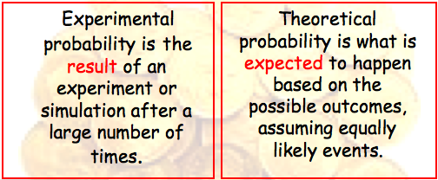  http://teachers.henrico.k12.va.us/math/ms/c20708/05ProbStat/5-1Probability.html
lowest common denominator | the smallest number you can use for denominators in order to add or subtract fractions  lowest = smallest  common = same  denominator = bottom number in a fraction 1  4 | 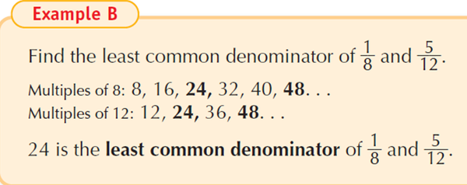  http://www.aldenschools.org/ | http://www.mathsisfun.com/least-common-denominator.html
interval | the numbers that are between two numbers  When you make a graph or number line, your intervals should be equal to each other.  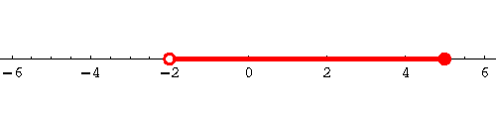  http://www.sosmath.com/ | Interval:  All the values between two given end points.  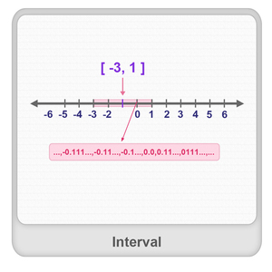  www.splashmath.com | http://www.mathsisfun.com/sets/intervals.html
mean | a way to measure data by:  - adding up all numbers  - divide that by how many numbers were added  (also known as the “average”) | 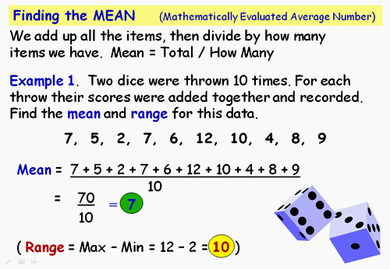  http://passyworldofmathematics.com/
measure of central tendency | different ways to measure data (mean, median, or mode) | 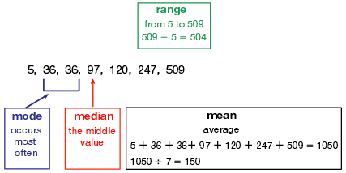  www.eduplace.com
median | a way to measure data by putting all of the numbers in order and then finding the middle number  If there are two middle numbers, add the two numbers together and divide by two to find the median. | 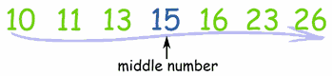  www.mathisfun.com
Multiplicative Identity | any number multiplied by 1 will give you the same number  5 * 1 = 5  1,238 * 1 = 1,238 | 3 * = 21  4 * = 28  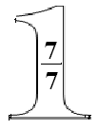  The giant one can be used to make equivalent fractions because it is equal to one.  http://en.wikiversity.org/
outcome | what happens during an event, the end result | 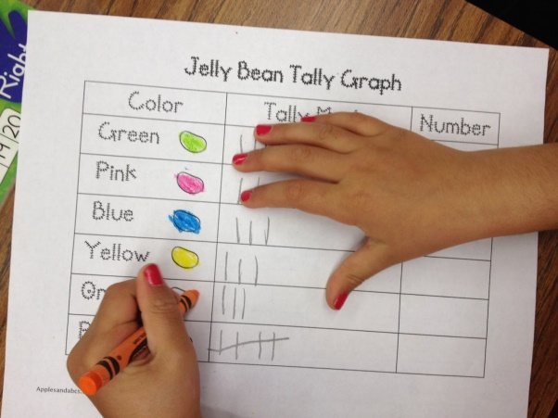  http://applesandabcs.blogspot.com/ | http://www.studyzone.org/testprep/math4/d/outcomel.cfm
outliers | a number that is not close to the other numbers in the data group | 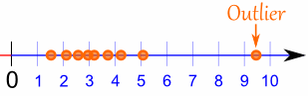  www.mathisfun.com
parallelogram | four sided figure that has two sets of parallel sides  http://www.wpclipart.com/ | 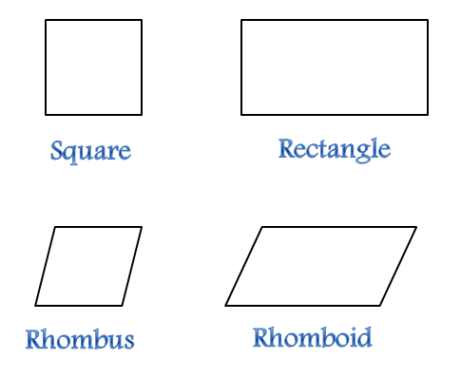  http://education-portal.com/
percent | a number out of 100  percentage sign = %  67 = 67%  100 | 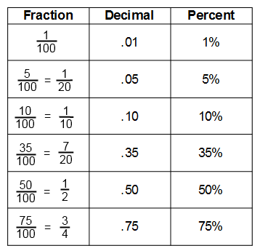  http://www.math4ged.com/ | http://www.mathsisfun.com/percentage.html
perimeter | the distance AROUND an object | 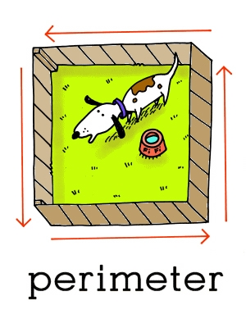  www.leslienettling.com | http://www.mathsisfun.com/geometry/perimeter.html  area vs. perimeter http://www.bgfl.org/bgfl/custom/resources_ftp/client_ftp/ks2/maths/perimeter_and_area/index.html
possible outcomes | what could happen | 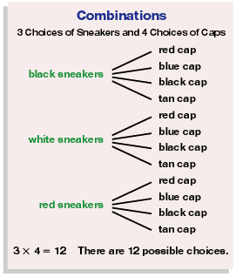  www.eduplace.com | http://www.studyzone.org/testprep/math4/d/outcomel.cfm
probability | a number that represents the chance of something happening | 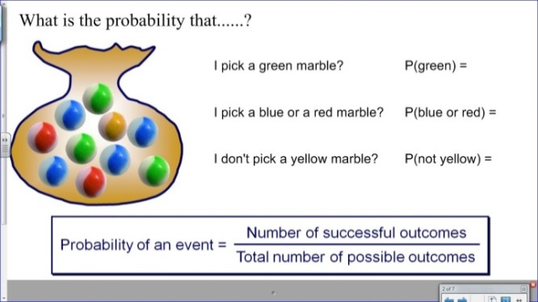  http://mrcollinsmaths.blogspot.com/ | http://www.mathsisfun.com/data/probability.html  http://www.mathgoodies.com/lessons/vol6/intro_probability.html
proportional relationship | two amounts that have the same ratio  Example:  If you babysit for 1 hour, you will get paid $9.00. If you babysit for 3 hours, you will get paid $27.  1 hour = 3hours  $9.00 = $27.00  When one is multiplied by 3, the other number is multiplied by 3. | 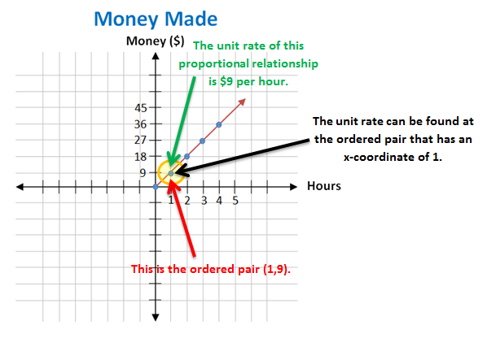  gcps.desire2learn.com | http://www.mathsisfun.com/definitions/proportional.html
rectangle | a four sided shape with all 90⁰ angles and 2 sets of parallel sides  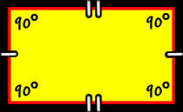  www.coolmath.com | http://euler.slu.edu/
repeating decimal | a number where after the decimal point, the number never ends and continues to repeat | 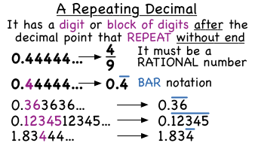  sites.google.com/a/d83.org
sample space | all of the possible outcomes | What is the probability of the spinner stopping on each of these colors?  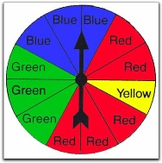  Sample Space: blue, red, yellow, green  Probabilities:  yellow: 1/12  Red: 5/12  Blue: 3/12 or ¼  Green 3/12 or ¼  picture from: http://math.about.com/ | Practice this: http://www.mathgoodies.com/lessons/vol6/sample_spaces.html
Scaling  (a graph) | writing numbers down on the axis or axes of the graph  This graph has intervals of 10. | 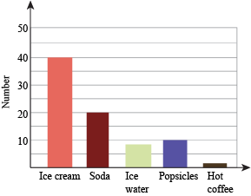  http://www.shmoop.com/
terminating decimal | 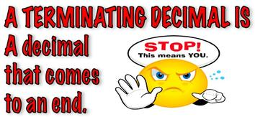  http://visual-math-vocabulary.wikispaces.com/ | .7  12.5167  0.239  381.2
theoretical probability | the probability of something happening based on what should happen | 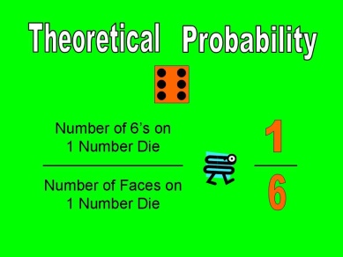  What is the probability of rolling a 6?  http://robertson4thgrade.edublogs.org/
trapezoid | a four sided figure with only one set of parallel sides  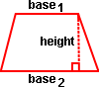  www.mathgoodies.com | 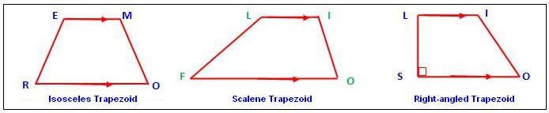  http://www.mathcaptain.com/
triangle | a three sided figure | 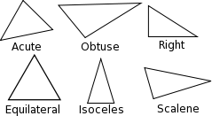  http://euler.slu.edu/

