Vocabulary Word | Definition | Picture | Learn more…
absolute value | the distance a number is from zero  The answer will always be positive (+). | 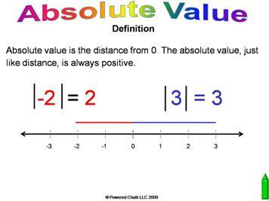
Additive Identity | adding the number 0 to any number does not change the value  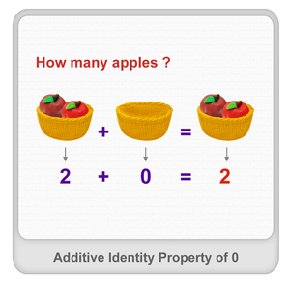  www.splashmath.com | 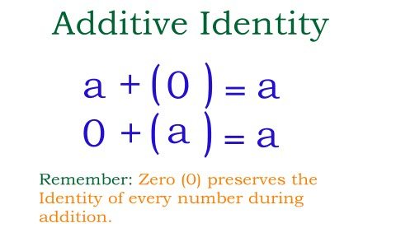  http://www.printable-math-worksheets.com/
Additive Inverse | adding the opposite of a number to get an answer of 0 | 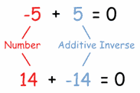  www.mathisfun.com
Distributive Property | Multiply the number outside of the parenthesis with everything inside the parenthesis.  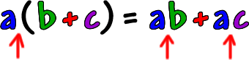  www.coolmath.com | 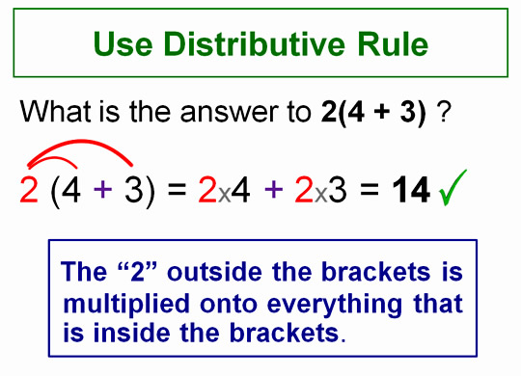  http://passyworldofmathematics.com/ | http://www.mathsisfun.com/definitions/distributive-law.html  http://www.mathwarehouse.com/dictionary/D-words/distributive-property-definition-and-examples.php
equivalent | to be equal or have the same amount | 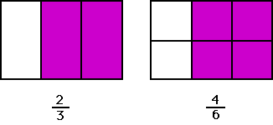  http://www.loisterms.com/
fraction greater than one | a fraction where the numerator (top number) is larger than the denominator (bottom number)  7 top number is bigger  2 | 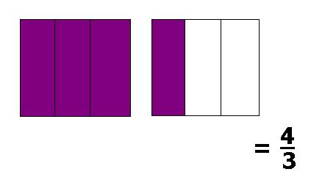  spfractions.wikispaces.com | Watch a video: https://learnzillion.com/lessons/1438-represent-a-fraction-greater-than-one-using-area-models
four-quadrant graph | a graph with 4 different areas to plot ordered pairs on  (also called a coordinate plane or graph) | 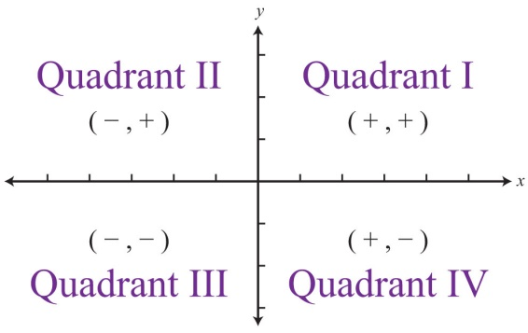  http://catalog.flatworldknowledge.com/
integers | the counting numbers; can be positive (+) or negative (-)  Integers can NOT be fractions. |  | http://www.mathsisfun.com/whole-numbers.html  Adding and Subtracting Integers  http://www.mathsisfun.com/positive-negative-integers.html
interval | the numbers that are between two numbers  When you make a graph or number line, your intervals should be equal to each other.  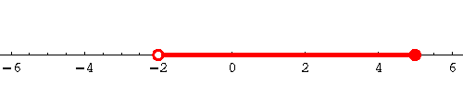  http://www.sosmath.com/ | 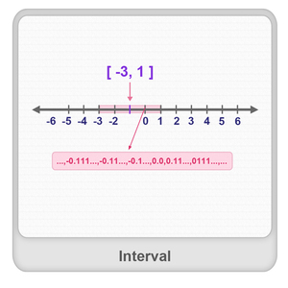  Interval:  All the values between two given end points.  www.splashmath.com | http://www.mathsisfun.com/sets/intervals.html
mixed number | a whole number with a fraction | 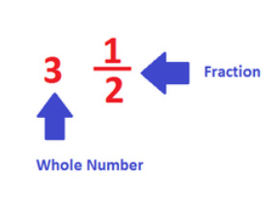  http://basicfractionfun.weebly.com/
rational numbers | numbers that can be written in a/b form or as a fraction  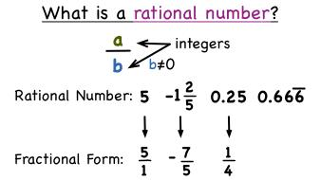  http://bhillmath.weebly.com/ | 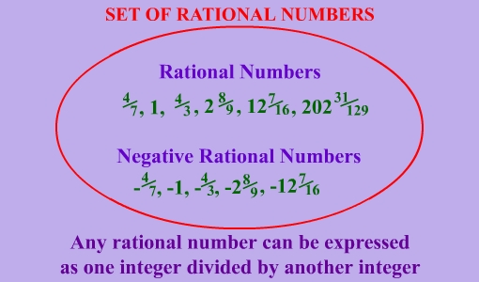  http://www.webovations.com/
repeating decimal | a number where after the decimal point, the number never ends and continues to repeat | 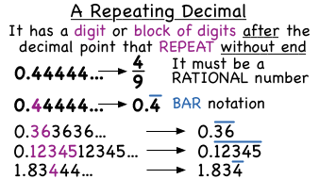  sites.google.com/a/d83.org
Scaling  (a graph) | writing numbers down on the axis or axes of the graph  This graph has intervals of 10. | 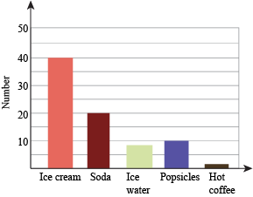  http://www.shmoop.com/
terminating decimal | 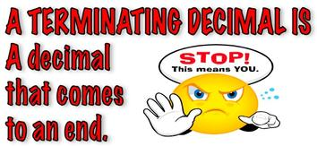  http://visual-math-vocabulary.wikispaces.com/ | .7  12.5167  0.239  381.2

