Vocabulary Word | Definition | Picture | Learn more…
combining like terms | combining terms (by adding or subtracting) that are similar to each other | 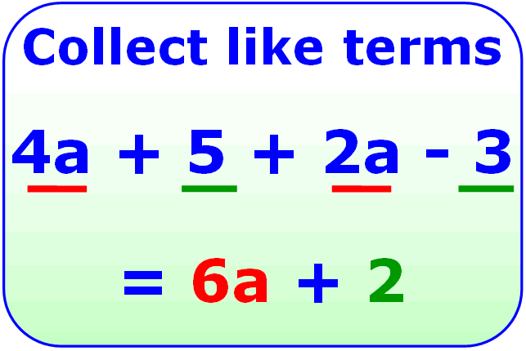  http://mjnwsu132.wordpress.com/ | http://www.mathsisfun.com/algebra/like-terms.html
continuous graph | a graph that has points that are connected | 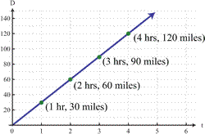  http://www.emathematics.net/ | Video on discrete vs. continuous graphs  https://learnzillion.com/lessons/2489-distinguish-between-discrete-and-continuous-graphs
dependent variable | this variable depends on the value of another variable  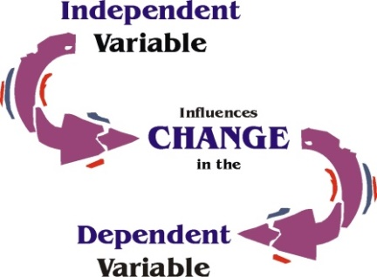  http://arose.iweb.bsu.edu/  It is usually shown as the output value in a table. | 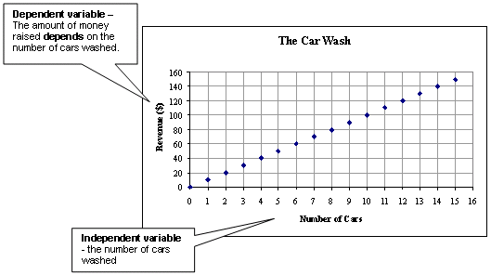  astro.virginia.edu
discrete graph | a graph with points that are not connected | 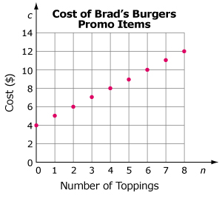  http://moodle2.rockyview.ab.ca/ | Video on discrete vs. continuous graphs  https://learnzillion.com/lessons/2489-distinguish-between-discrete-and-continuous-graphs
Distributive Property | Multiply the number outside of the parenthesis with everything inside the parenthesis.  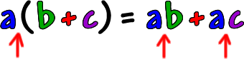  www.coolmath.com | 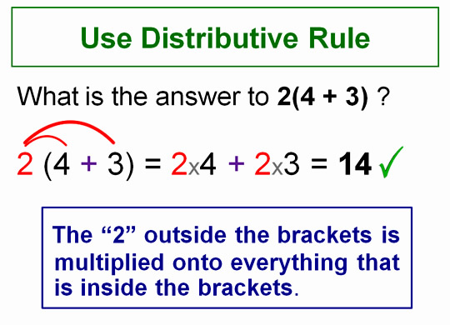  http://passyworldofmathematics.com/
evaluate | to put in numbers for the variables (letters) in an algebraic expression | Evaluating an algebraic expression:  6b + 5 where b = 2  (6 * 2) + 5  12 + 5  17 | Watch a video:  http://www.mathplanet.com/education/pre-algebra/introducing-algebra/evaluate-expressions
independent variable | this variable will change the value of another variable  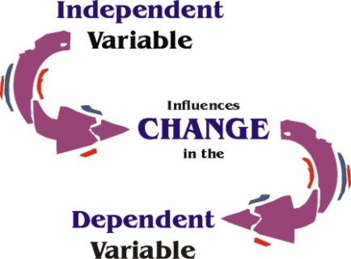  http://arose.iweb.bsu.edu/  It is usually shown as the input value in a table. | astro.virginia.edu
Order of Operations | the order to evaluate or simplify an expression  - Parentheses ( )  - Exponents 5²  - Multiplication (*) and Division (÷) (left to right )  - Addition (+) and Subtraction (-) (left to right ) | 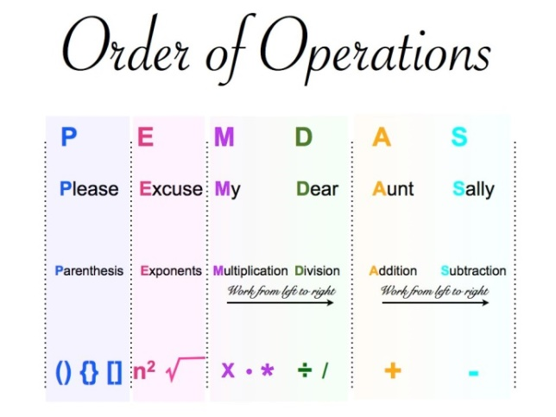  http://www.kidzucation.com/
parabola | U-shaped curve on a graph  y = ax² + bx +c  where a does not equal 0  (can open up or down) | 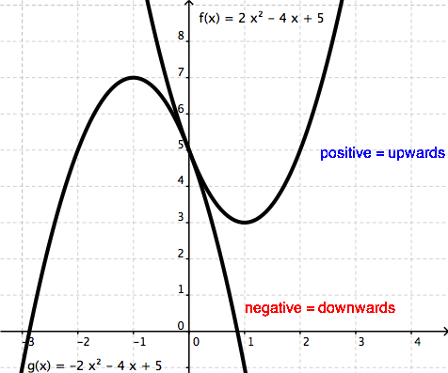  http://www.wyzant.com/
solution | the answer(s) to an equation  or inequality ≤ | 10 = x + 3  -3 = - 3  7 = x  7 is the solution for this equation
term | a number, a variable, or a number multiplied by variable/variables | Number = 23  Variable = b  Number and Variable(s) = 12y or 5ab
variable | a letter that represents an unknown value | 2x + 8 – 9y  Variables
vertex | the point where two lines or rays meet  vertices = more than one vertex  can also be a corner of a shape | 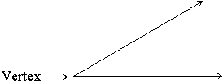  http://www.resourcechannel.org/  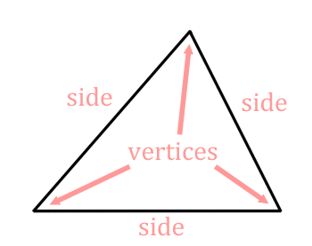  www.mathguide.com
Vertex (parabola) | the highest or lowest point of the parabola | Vertex on a Parabola  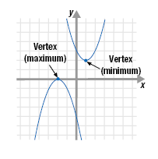  http://www.mathsite.org/
x-intercept | the point where a line meets the x-axis | 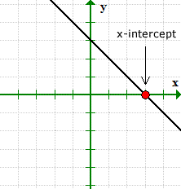  http://www.chilimath.com/
y-intercept | the point where a line meets the y-axis  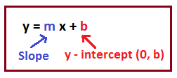  http://math.tutorvista.com/ | 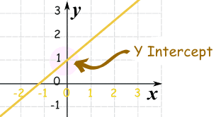  http://www.mathsisfun.com/

